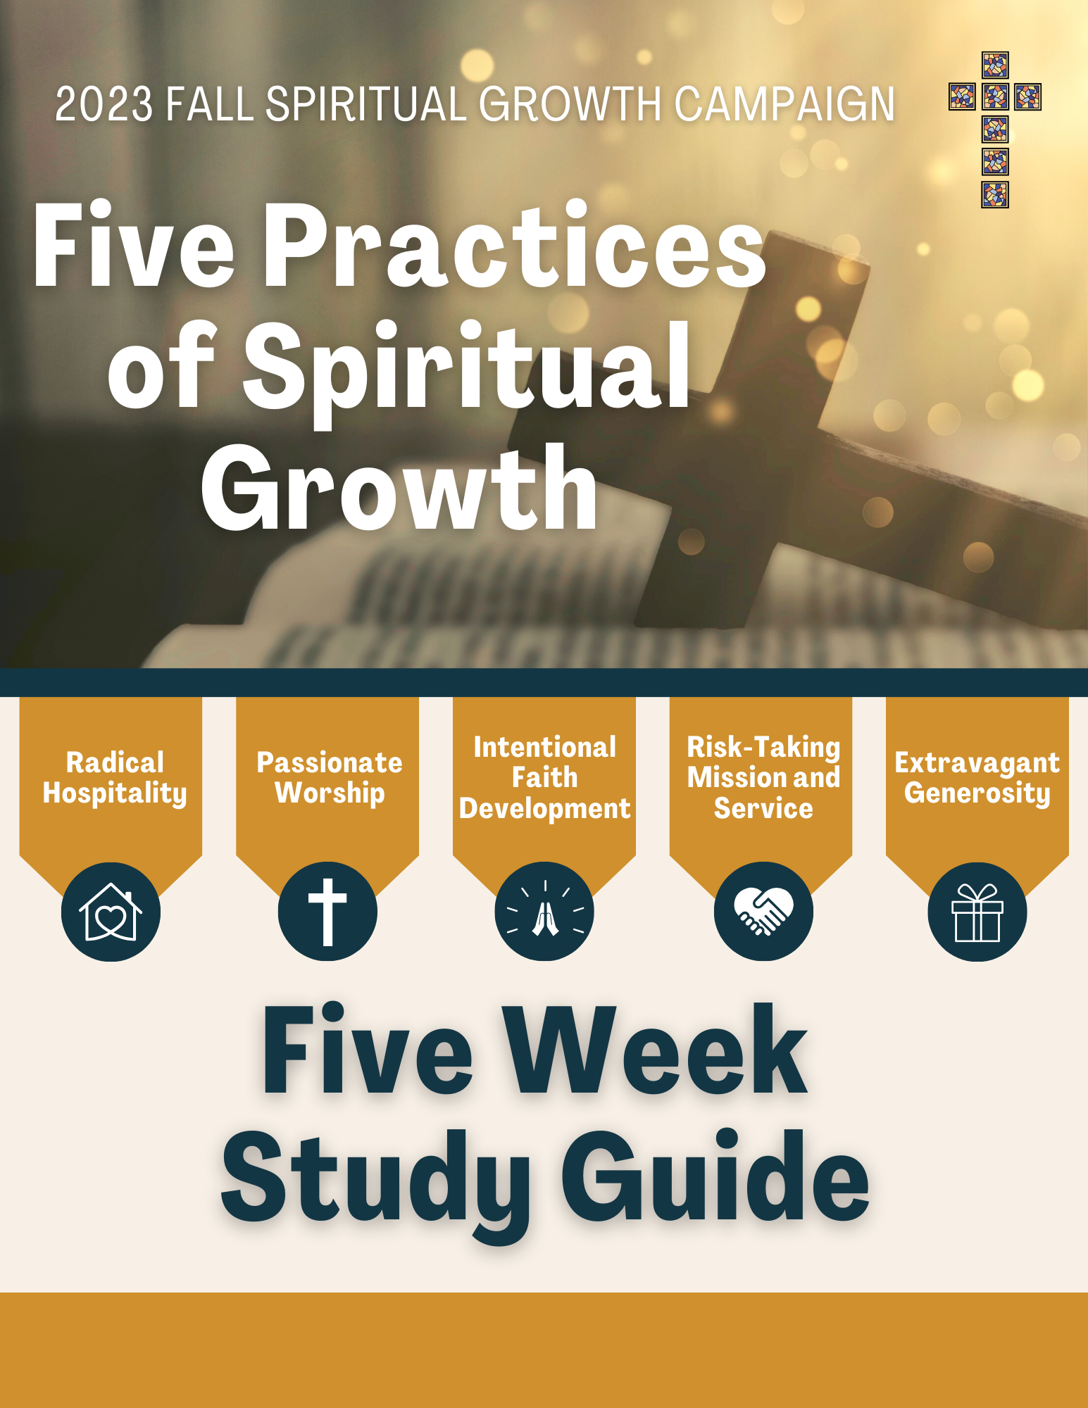

**Fall Spiritual Growth Campaign Study Guide – September 17, 2023**

**Week 1 - Theme: Radical Hospitality (Begin by watching the introduction video – oursaviorlansing.org - “livestream”**

Robert Schnase, author of the book ***Five Practices of Fruitful Congregations*** writes this about radical hospitality: “*Radical describes practices that are rooted in the life of Christ and that radiate into the lives of others. Radical means drastically different from ordinary practice, outside the normal, and so it provokes practices that exceed expectations, that go the second mile, that take welcoming the stranger to surprising new levels. By radical, I don’t mean wild-eyed, out of control, or in your face. I mean people offering the absolute utmost of themselves, their creativity, their abilities, and their energy to offer the gracious embrace of Christ to others.”*

Schnase, Robert C. *Five Practices of Fruitful Congregations*. Nashville, Abingdon Press, 2018.

**Getting Started: (sharing with each other)**

1. Tell about a place you have visited that did an excellent job of being hospitable and making you feel special. It could be a trip, another city or country, a restaurant, hospital, resort, etc.
2. In what ways (or in what types of situations) do you “roll out the red carpet” for other people?

**In the Word:** Read Romans 12:9-18

1. In verse 9, Paul tells us to be ***sincere*** and ***genuine*** in our love for others. Give examples of sincere and genuine love.
2. Talk about different opportunities we have to *“…not be haughty, but associate with the lowly.”* (Romans 12:16 – ESV)
3. In question two, you talked about “rolling out the red carpet” for others. In Romans 12:13, Paul implores us to seek to show hospitality to others. How can we do this as individuals? How can we do this as Christ’s body of believers (the church)?
4. In Romans 12:16 we are told to live in harmony with one another. In music, harmony is two or more notes that are sung together. People are like notes in a chord. When the chord sounds pleasant, all the notes are getting along. Sometimes, however, there is tension, and the notes seems to clash. These differences also produce beautiful music out of what can seem like discord. Talk about the ways that this is so with Christians within our church and within the community.

Read Luke 19:1-10

1. Jesus showed radical hospitality toward Zacchaeus. In what way is this story of Jesus’ interaction with Zacchaeus a small representation of our Heavenly Father’s radical hospitality toward us?
2. In what ways is the Holy Spirit working in Zacchaeus even before his interaction with Jesus?

**Putting it all Together (what do we believe or do as disciples?)**

1. Are there times when you pretend to love others? In other words, are there people or situations that are difficult to love, but you endure it/them anyway?
2. Write down a list of things to do and not to do according to Romans 12:9-18

DO… DO NOT….

1. In Romans 12:10 it says to honor others above ourselves. What does that mean, and what are some ways to do that?

Prayer: Thank God for His radical hospitality toward us. Confess to God that you have not always looked outside your comfort zone to show hospitality toward others. Pray that the Holy Spirit would move you to look for more ways to show hospitality toward other people.

**Fall Spiritual Growth Campaign Study Guide – September 24, 2023**

**Week 2 - Theme: Passionate Worship (Begin by watching the introduction video – oursaviorlansing.org - “livestream”**

“*Worship can be a troublesome word. Who begins the act of worship? What or whom is being worshiped? It is at this point where we can become confused and begin to think that God has come to be entertained by us, that somehow what we say and do in the worship service makes us more worthy of God’s free gift of love. Nothing in the worship service – not the candles, not the flowers, not the music, not the prayers, not the praise – makes us worthy of anything before God. We do not appease God’s wrath, nor do we earn His forgiveness by anything we do. Rather, it is ‘Jesus who delivers us from the wrath to come’ (1 Thessalonians 1:10).*

*In the Divine Service, God provides His service for us. In the reading, the preaching, and the proclamation of His word, in His sacraments of Holy Baptism and Holy Communion, God comes to us. The work we do in worship is to receive the gift of God’s grace and respond.”*

Kinnaman, Scot A., editor. “Chapter 27, What Is Worship and the Divine Service?” *Lutheranism 101*, Concordia Publishing House, St. Louis, 2021, pp. 205–206.

**Getting Started (Sharing with each other)**

1. What parts of worship are the most impactful for you?
2. Are you more comfortable with traditional hymns or contemporary praise music?

**In the Word:** Read John 4:19-30 & 39

1. What does Jesus mean in verse 22 when He tells the Samaritan woman that she worships what she does not know, but that the Jewish people worship what they know?
2. From verses 23 and 24, how do we worship in Spirit and truth?
3. What is significant about verse 39?

Read 2 Samuel 6:12-22

1. In what ways were David’s and Michal’s attitudes about worship different?
2. In what ways do people today have different attitudes and expectations about worship?

**Putting it all Together (what do we believe or do as disciples?)**

1. From the quote on the previous page from Lutheranism 101, in what ways can and should we, as Lutherans, be passionate about worship?
2. God gives to us in worship. We receive His good gifts and then respond. What are some internal ways and external ways that we can be more responsive to God in worship?

**Prayer:** Pray for unity within our congregation. Pray for God to be honored and glorified by our response to Him and His gifts during worship. Thank God for the gift of His Son Jesus and the privilege to partake of His body and blood during Holy Communion. Ask God to make us conscientious toward the needs of people we know who do not worship regularly. Pray for courage to offer your church to others.

**Fall Spiritual Growth Campaign Study Guide – October 1, 2023**

**Week 3 Theme: Intentional Faith Development (Begin by watching the introduction video – oursaviorlansing.org - “livestream”**

Intentional: Done in a way that is planned; done on purpose.

It is unlikely that you wake up each day suddenly enlightened and informed about a particular topic unless you recently spent time reading about that topic, immersing yourself in that situation or environment, studying, and thinking about that topic. Likewise, one does not become spiritually enlightened, educated, and have his or her faith increased if intentional effort has not been put into it.

Intentional faith development is planned. It is not accidental.

The Holy Spirit has called us to faith. It is an intentional calling. Without it, Luther calls us all spiritually blind and dead. Someone who is blind and dead is unable to intentionally do anything. According to the meaning of the 3rd Article of the Apostle’s Creed, “*apart from the Holy Spirit, I actively resist the Gospel’s call to faith in Christ.*” In the following question in the catechism it asks, “*What does it mean that the Holy Spirit has called me by the Gospel?* Here is the response: “*Through the Gospel, the* *Spirit* *both invites and enables me to believe by promising me a new life on the basis of Christ’s death and resurrection.”* Finally, one key question asks about our sanctification. Here is the response; “*The Holy Spirit then sanctifies me by strengthening my faith and increasing its fruit within my life. He gives me new desires so that I strive to overcome sin and do good works.”*

(Luther’s Small Catechism, 2017, questions 187-188, 190)

In a very real and necessary way, when we allow the Holy Spirit to work in our lives, we become part of God’s faith development within our life. After all, intentional faith development enables us to believe with a stronger faith. It enables us to bear good fruit. It enables us overcome sin. It enables us to desire new and better things – things of God, rather than selfish, sinful desires.

**Getting Started (sharing with each other)**

1. What types of projects do you like to do around the house? Building things? Rearranging rooms? Installing new flooring or windows or lighting fixtures?
2. Unless you are naturally gifted, how do you accomplish those tasks that were just mentioned? Do you watch a You tube video, read instructions, watch a home improvement show, stop by a construction site and ask questions, or just wing it.) Talk about the way you plan as you do home improvement projects. (Home improvements and other projects don’t just happen. There is an intentionality in order to improve something.)

**In the Word: Read 2 Peter 1:3-9**

1. List the various positive character qualities that Peter mentions in these verses.
2. In what ways are verses 3 & 4 a foundation for verses 5-9?
3. In verse 9, Peter hash some harsh words for those who do not seek to possess the qualities he mentions. In what ways are people nearsighted and blind?

**Read Luke 17:1-10**

1. The disciples asked Jesus to increase their faith. What are some basic things they struggled to do (verses 3-4)?
2. In verses 7-10 Jesus is basically telling the disciples what?

**Read Acts 17:10-12**

1. What can we learn from the Jews in Berea?

**Putting it All Together (what do we believe or do as disciples?)**

1. How can we tie together Luke 17:7-10 above with our response to the Holy Spirit? In other words, what can we be doing to intentionally develop our faith?
2. What useful gifts has God given us and how can we use them to intentionally develop a deeper faith?

**Prayer:** Thank God for the gifts of the Holy Spirit – gifts of faith, desires to seek God’s will, sanctification. Ask for God to continue to increase your faith. Pray for discipline and consistency in using God’s gifts of worship, the Bible, prayer, sacraments, Bibles studies, etc.

**Fall Spiritual Growth Campaign Study Guide – October 8, 2023**

**Week 4 Theme: Risk-Taking Mission and Service (Begin by watching the introduction video – oursaviorlansing.org - “livestream”**

David Platt, in his book ***Counter Culture*** bares his heart as he pleads with Christians to truly practice the gospel. He writes, “*We spend the majority of our time sitting as spectators in services that cater to our comforts. Even in our giving to the church, we spend the majority of our money on places for us to meet, professionals to do the ministry, and programs designed around us and our kids. What in the world are we doing? Or better put, what in the* ***word*** *are we doing? We have filled even the most Bible-believing churches with so much that is not in the bible. I can’t help but wonder what might happen if we put aside our personal preferences, let go of our extrabiblical (and in some cases unbiblical) traditions, laid down our cultural comforts, and organized ourselves solely and sacrificially around God’s word and gospel mission.*

*Are we going to choose comfort, or are we going to choose the cross?”*

Platt, David. *Counter Culture : Following Christ in an Anti-Christian Age*. 2015. Carol Stream, Illinois, Tyndale Momentum, The Nonfiction Imprint Of Tyndale House Publishers, Inc, 2017, pp. 241–242.

**Getting Started (sharing with each other)**

1. Talk about the David Platt statement. Is it accurate? Fair? Thought-provoking?
2. What do you think of when you think about “risk-taking mission and service?” What types of risks might be involved when we allow God to work through us?

**In the Word: Read Hebrew 11:8-19**

1. What enabled the Old Testament heroes (Noah, Abraham, Enoch, etc) to follow God?
2. Read Hebrews 11:1. What is a certainty when it comes to things we do not see?
3. In verses 8-10 it talks about Abraham getting up and moving to a foreign country. He did so without hesitation because he was looking forward to what? What was the big picture that Abraham focused on?
4. In verse 13 we read that all of these heroes died while not yet receiving the promises of their faith. What does that mean? Are those of us who call ourselves Christians today in a similar position?

**Read Luke 10:1-9**

1. In verse 2, Jesus tells the seventy-two to do what first? In what other life areas is that instruction applicable?
2. What sounds discouraging in verses 3-4? Why did Jesus set these parameters?

**Read 1 Kings 19:1-4**

1. This seems like more discouragement when it comes to going out of your comfort zone and following God’s directives. Elijah triumphed over the prophets of Baal on Mt Carmel, yet still found his life in great danger. Talk about risk-taking mission and service! Put yourself in Elijah’s shoes (or sandals). Discuss in your group what it might feel like to step out in faith even if people wanted to take your life because of your faith.

**Putting it all Together (what do we believe or do as disciples?)**

1. How can we serve others and share Christ even when it might be risky?
2. Finally, which situations and people close to home can be scary when it comes to sharing your faith?

**Prayer:** Pray that God would provide many workers for the harvest that is before us. Pray that God would give you courage to step out in faith as God calls you. Thank God for His eternal protection and deliverance for all His people.

**Fall Spiritual Growth Campaign Study Guide – October 15, 2023**

**Week 5 Theme: Extravagant Generosity (Begin by watching the introduction video – oursaviorlansing.org - “livestream”**

*“St. Paul encouraged the believers in Corinth to “decide in their heart what to give, not reluctantly or under compulsion, for God loves a cheerful giver” (2 Cor. 9:7). It is the love God first showed us in our crucified and risen Savior that frees us to make our offering cheerfully. Our giving is a response to such love, a privilege to help proclaim the news of forgiveness and salvation found in Christ.*

*Although tithing is a healthy guideline, the percentage of our income we offer is not really the issue. Rather, the issue is what is found in the heart of the giver. Jesus made this point as he observed the widow putting in her offering, which, in comparison with others, was meager, yet elicited His highest praise because of the sheer trust and thanks with which she gave (Luke 21:1-4).*

*Because all that we own and all that we earn belong to God, we, by our offering, merely give back a portion of that with which He has blessed us. It is faith that grasps this reality, in spite of the temptation to find security in material possessions, as the Scriptures promise: ‘Whoever trusts in his riches will fall, but the righteous will thrive like a green leaf (Prov. 11:28).’”*

Schroeder, Randy. “Faithful Tithers.” *The Lutheran Witness*, 1 Jan. 2007.

**Getting Started (sharing with each other)**

1. Tell about an experience in which you experienced generosity from someone else.
2. Share about a time when you were excited to give a gift.

**In the Word: Read Exodus 36:2-7**

1. In the ESV version, verse 2 says, “…..*everyone whose heart stirred him up to come and do the work.”* Is the giving of our time, talents, and treasure something that hinges upon our heart being into it? In other words, if our *heart* is not stirred up to give, but we go through the motions of giving anyway, does God accept our offerings? (See Genesis 4:2-7)
2. What does it take for one’s heart to be stirred up to a point of generosity?
3. As Moses oversaw the construction of the tabernacle, he actually had to tell the people to stop bringing their offerings and contributions. They had more than enough to complete the project. Share with each other stories of God providing more than enough in your life or the lives of friends/relatives.

**Read 1 John 3:16-19**

1. How do we know when God’s love abides in us?
2. In what ways can we lay down our lives for our brothers/neighbors?

**Read Luke 21:1-4**

**Putting it all Together (what do we believe or do as disciples?)**

1. The introduction video to this week’s study had some humorous elements. Hopefully we all can laugh about those in the video being super ready and willing to help out Pastor Chris. The widow who gave all she had is a more serious example of a faith that combines belief with action. Clearly, it is not the amount that we give, but rather the trust in which we give. How much do we trust God in giving back a portion of which He has given to us? (just think about that one…no need to answer in the group) Share with each other: Where is God calling us to be more extravagant when it comes to giving? In other words, who is God putting in our path that we can help? What situation is the Holy Spirit prompting you to do something about? (Extravagant generosity does not just mean financial giving.)
2. We are given a glimpse of the early Christian church in Acts 2:44-47, *“ All the believers were together and had everything in common.****45****They sold property and possessions to give to anyone who had need.****46****Every day they continued to meet together in the temple courts. They broke bread in their homes and ate together with glad and sincere hearts,****47****praising God and enjoying the favor of all the people. And the Lord added to their number daily those who were being saved.”*

Is it realistic to think we could experience that type of Christian living today in 2023? How can Christian small groups (or maybe just your small group) be in community with one another and living generously toward one another?

**Prayer:** Thank God for His extravagant generosity toward us. Pray for a resolve to live generously in your interactions with others.